Figure 1 and Figure 2 on this page shows the results generated by computeCost and gradientDescent.

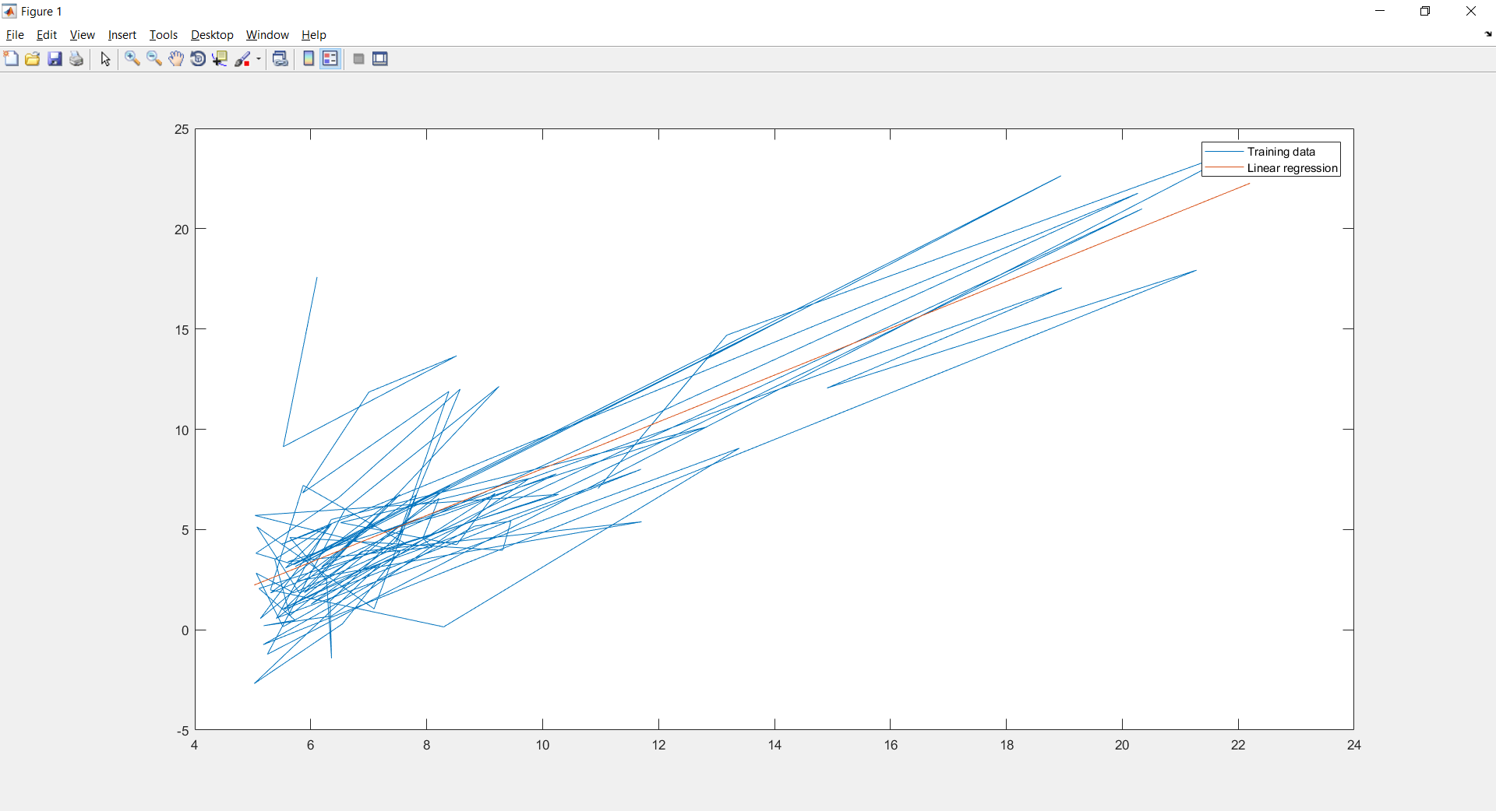

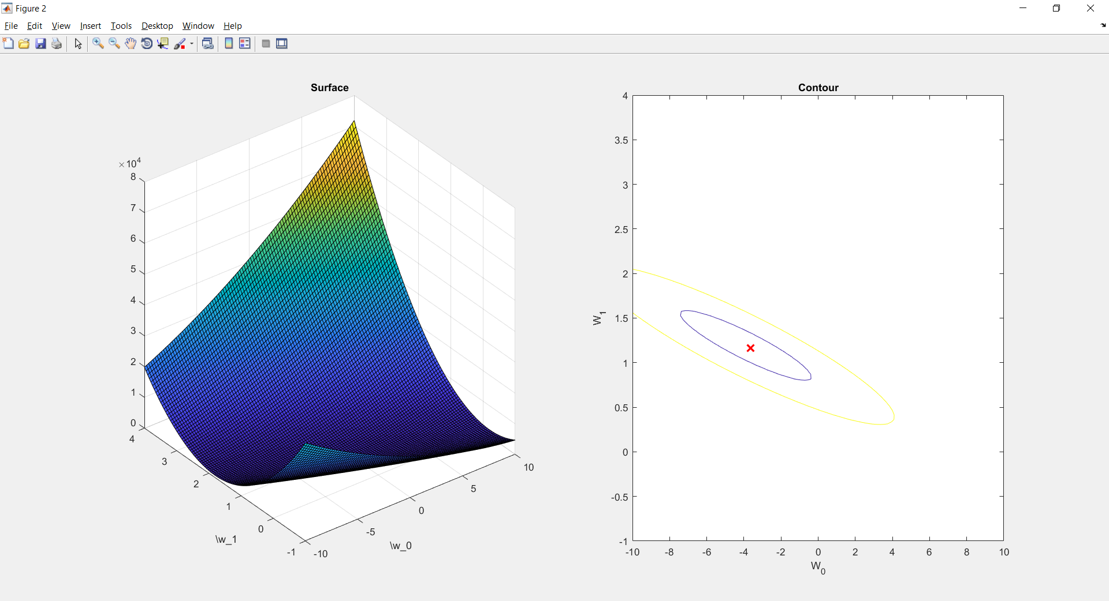

Below are the weight values generated by costCompute and gradientDescent

W = [-3.6303; 1.1664]

Figure 1 below shows the results generated by regression function.

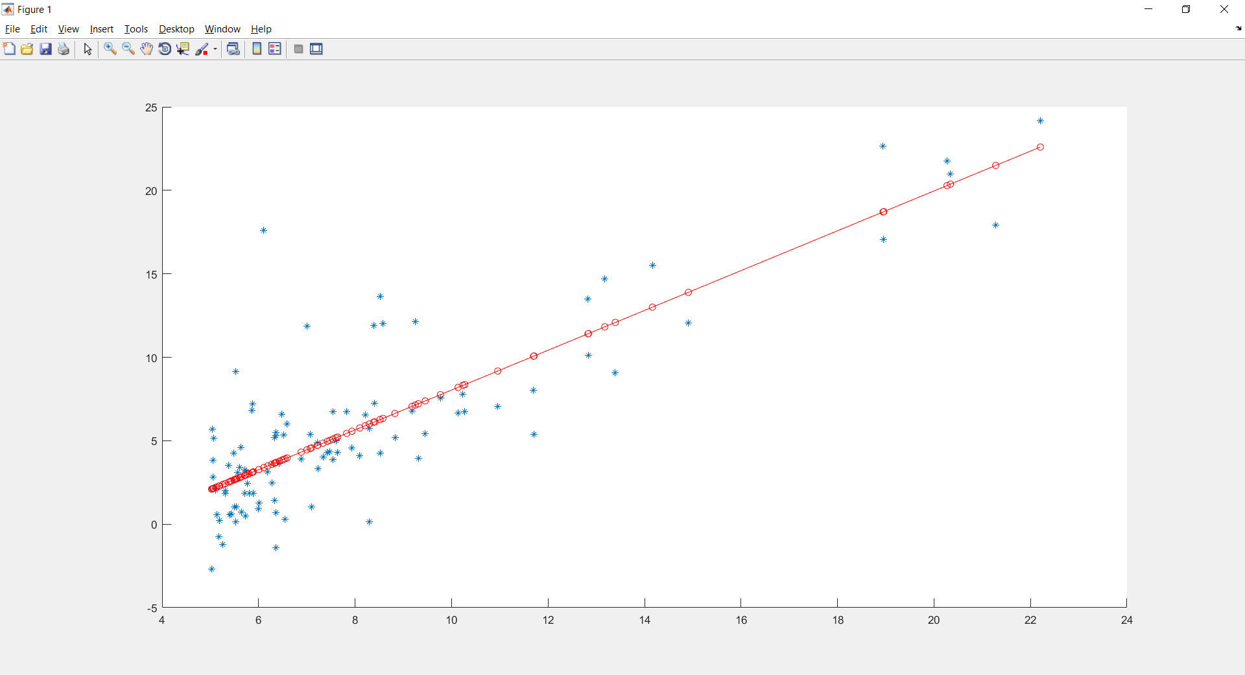

Below are the weight values generated by above regression function

W = [-3.8958; 1.1930]

From the above weight values, we can compare and say that both the values are identical to eachother.